Assembly Guide
The PID Controller board is being designed as a practical laboratory experience for students in a Feedback and Control of Dynamic Systems class. The assembly of the boards requires that you choose a plant (a 4th order low pass filter (LPF)) from the table below. Since the plants for the board are different, the PCB does not have component values for the discrete components used in the filter and instead use labels (given in the schematic below) which are populated by components whose values create different filter types shown in the table below.
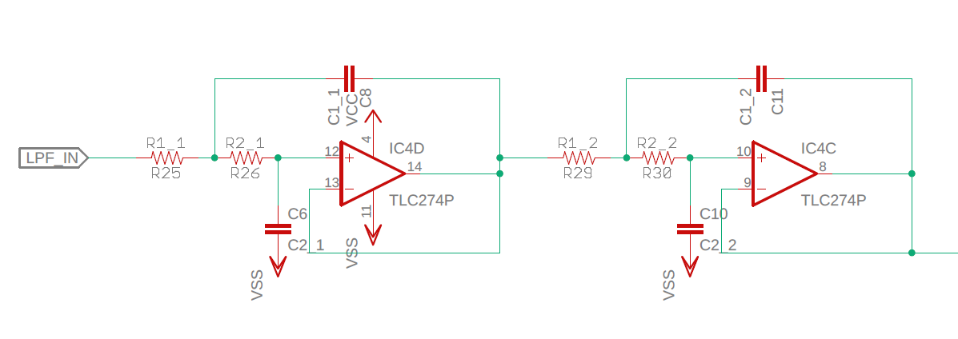
Note, the filters were designed using the Analog Devices, Analog Filter Wizard using the following parameters.
 | -3dB Chebyshev | -1dB Chebyshev | Butterworth | Bessel
Pass | -3dB @ 100Hz | -3dB @ 100Hz | -3dB @ 100Hz | -3dB @ 100Hz
Stop | -40dB @ 300Hz | -40dB @ 300Hz | -40dB @ 400Hz | -40dB @ 500Hz
Resp | -3dB Chebyshev | -1dB Chebyshev | Butterworth | Bessel
Opt | Voltage Range | Voltage Range | Voltage Range | Voltage Range
Capacitor | E6 | E6 | E6 | E6
Resistors | E6 | E6 | E6 | E6
R1_1 | 68kΩ | 33kΩ | 15kΩ | 10kΩ
R2_1 | 100kΩ | 68kΩ | 22kΩ | 15kΩ
C1_1 | 100nF | 100nF | 100nF | 100nF
C2_1 | 22nF | 33nF | 68nF | 68nF
R1_2 | 150kΩ | 100kΩ | 22kΩ | 10kΩ
R2_2 | 330kΩ | 150kΩ | 100kΩ | 22kΩ
C1_2 | 100nF | 100nF | 100nF | 100nF
C2_2 | 680pF | 1.5nF | 10nF | 33nF

Other than taking a long time, there should be no challenges during the assembly. Your board should look something like the one in Figure XXX.

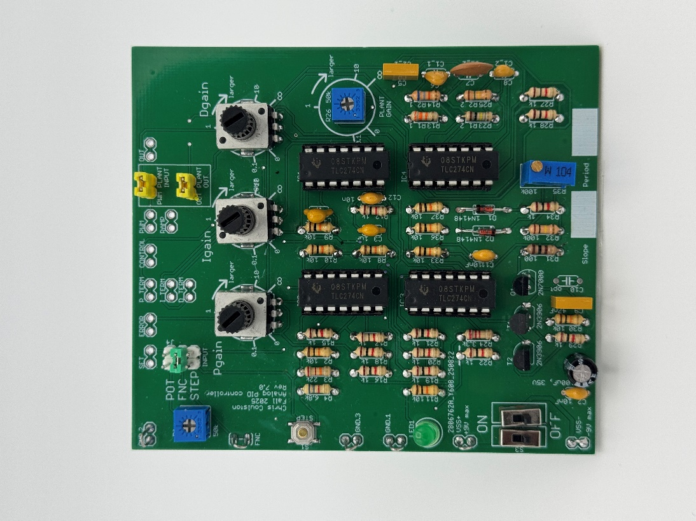

However, once the board is assembled, you will have to tune the ramp generator using the 100k 20-turn potentiometer R35. In order to do this, you need to understand a little about the circuit that generated the ramp, shown in Figure 1.
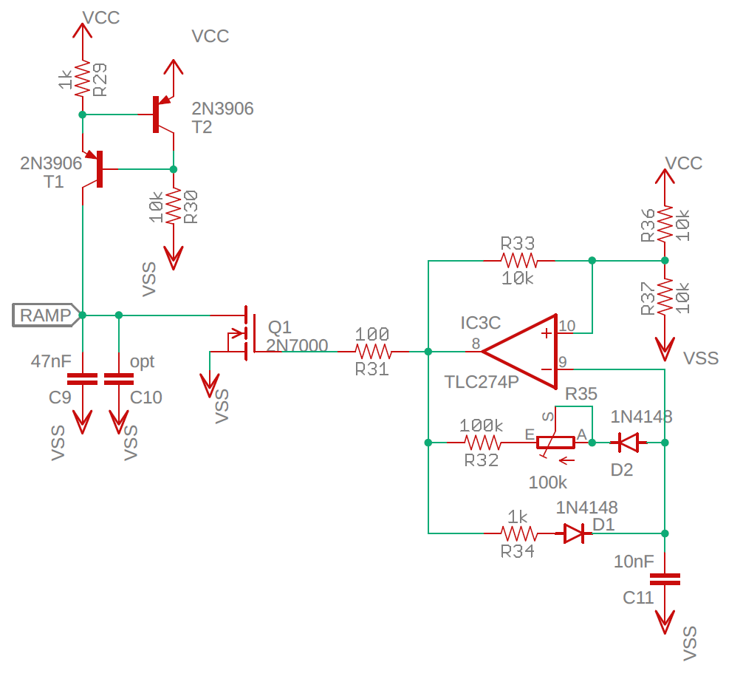
Figure 1: Ramp generator subsystem.

On left side of Figure 1 is a current source formed by R29, R30, T1 and T2. This current source generates about 0.7mA of current that flows onto the top plate of the 47nF capacitor C9. Since the current and capacitance are constant, we know that dv/dt is constant forming the ramp voltage available to the rest of the circuit as the RAMP signal. However, the RAMP voltage will quickly reach VCC. As soon as this happens, the gate of the MOSFET Q1 needs to be driven high, causing the drain and source to short, resetting the RAMP signal back to VSS. Control of the MOSFET’s gate is handled by the Schmitt Trigger relaxation oscillator (STRO) formed by the opamp IC3C and its associated discrete components. The period between discharging the top plate of capacitor C9 is, in part, determined by the 100k trimmer potentiometer R35.
When first assembled, you will need to adjust the trimmer pot R35 so that the RAMP signal (available on the header at the top of the board), ramps up from -9V to +9V with no dead time at +9V. In practice, you will have to reset RAMP before it reaches +9V, because the NPN transistor forming the current source will saturate when its emitter/collector junction approaches 0.3V. Once you get this POT set, leave it along.

